Nama ; Aldi muhamad fauzi

120707070013

Praktikum pcd modul 9

HASIL FILTER SOBEL

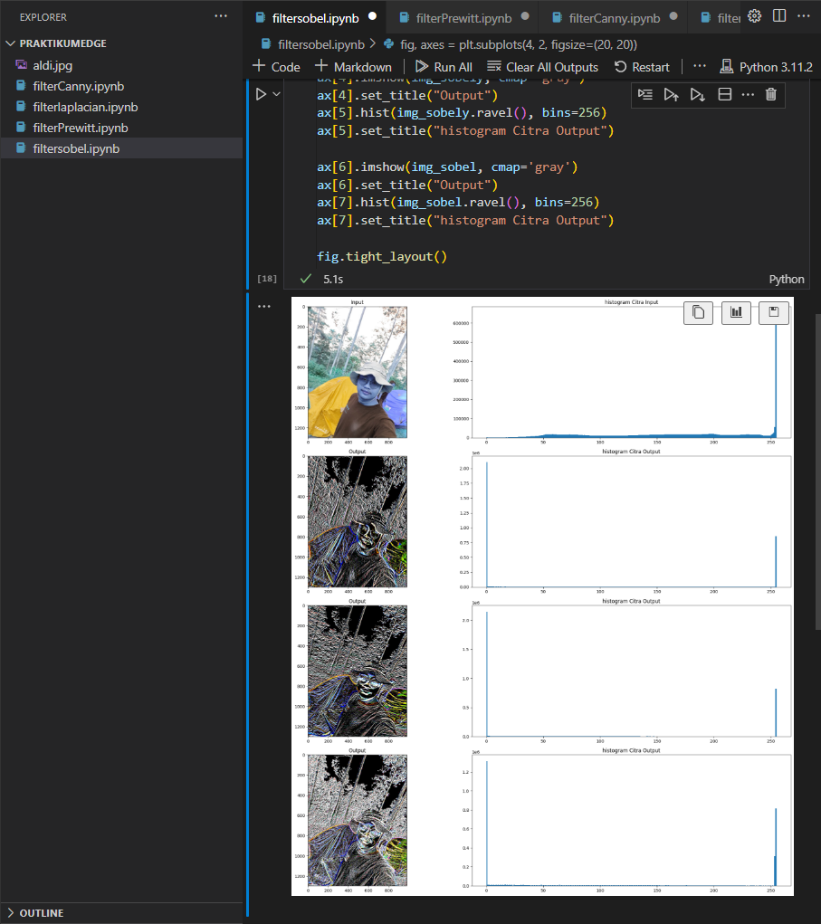

HASIL PREWITT

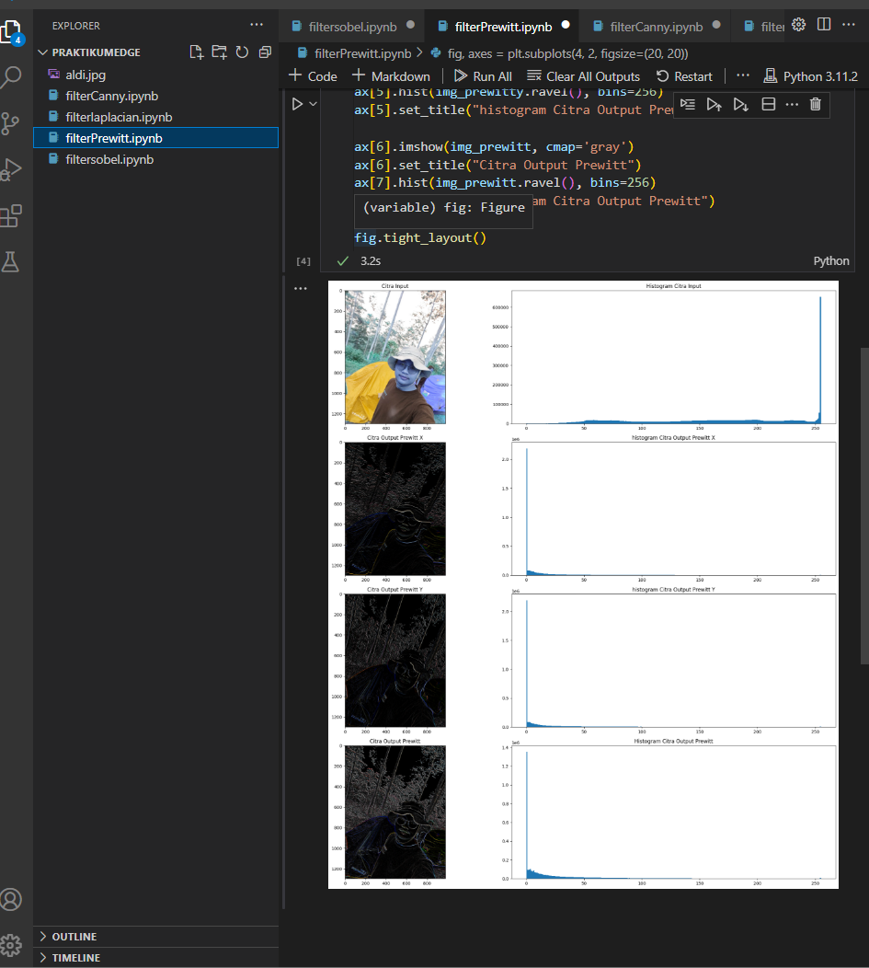

HASIL FILTER CANNY

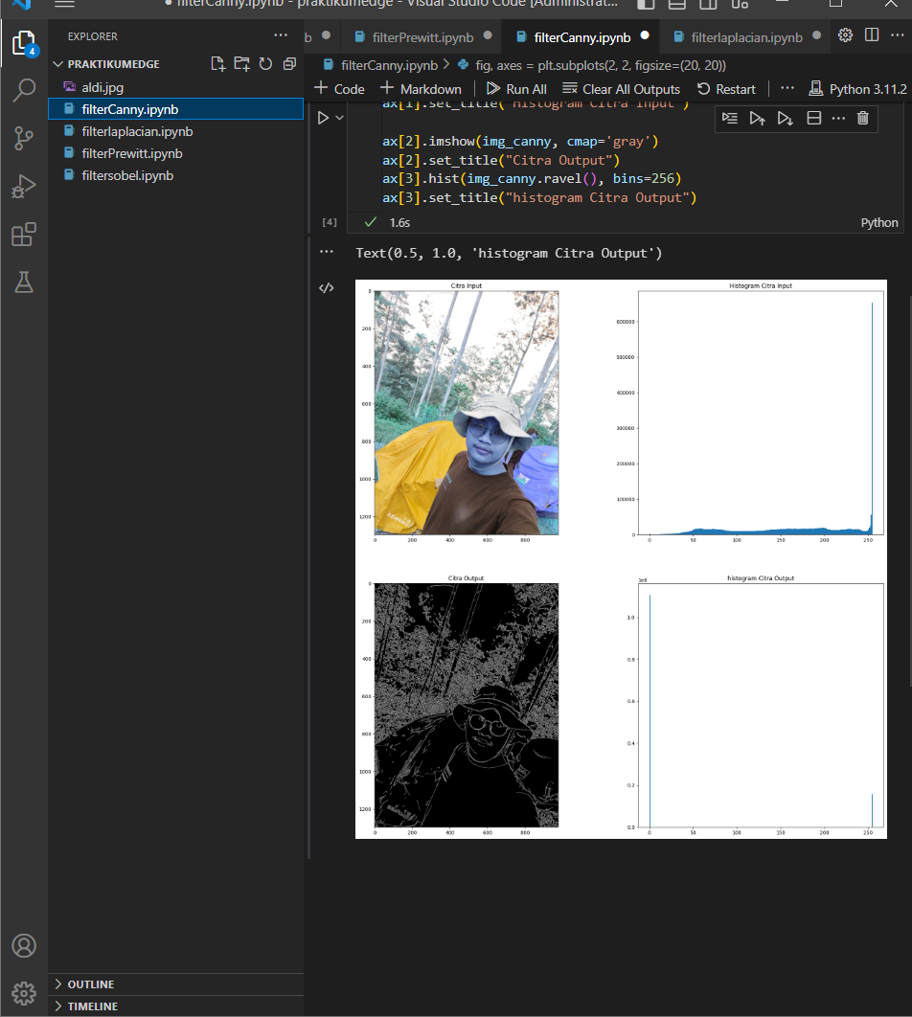

HASIL FLTER LAPLICAN

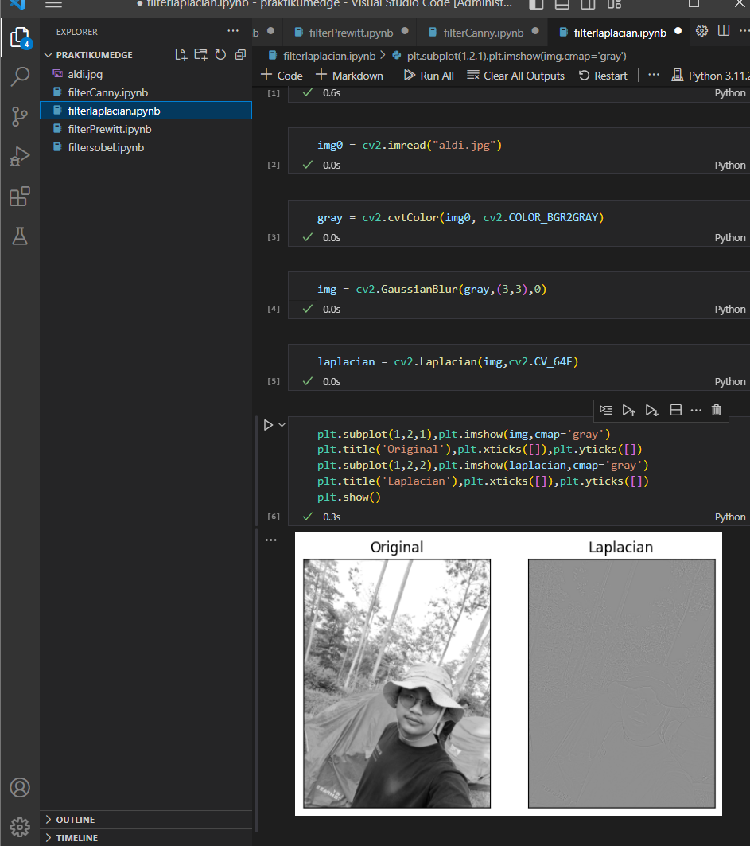

HASIL ANALISIS PERBEDAAN OUTPUT

